SQL Server

Connection to SSMS (SQL Server Management Studio)

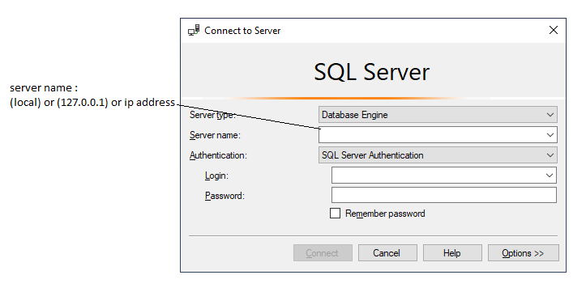

In SQL Server Authentication, Login-Password are required.

In Windows Authentication, Login-password are not required as authenticated by windows itself.

SSMS and SQL Server both are different.

SSMS (SQL Server Management Studio)

SSMS is client tool used to connect or communicate with SQL server (Database Server). SSMS is not the server by itself. We connect SSMS to database server by specify server’s configuration in it.

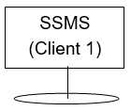



Database Server

Object Explorer in SSMS

Object explorer shows all SQL server objects.

SQL server objects are:

1. Database
2. Trigger
3. Stored Procedure
4. Functions
5. View

Open Object Explorer: -

View -> Object Explorer

System Databases:

These databases installed automatically at the time of installation of SSMS. These are required for the proper functionality of the SSMS.

System Databases are:

1. master
2. model
3. msdb
4. tempdb